

**COMSATS University, Islamabad**

**Experiment # 4**

**Conversion of Galvanometer into Ammeter**

**Author: Muhammad Mujtaba**

**SP22-BSE-036**

**Course: Applied Physics for Engineers (PHY-121)**

**Instructor: Dr. Lubna Tabassum**

**Date: April 24, 2022**

**OBJECTIVES:**

This experiment is designed to convert sensitive galvanometer into ammeter. The ammeter would measure current ranging from **0 mA** to **10mA**.

**APPARATUS:**

* Galvanometer
* Variable resistor / potentiometer
* Resistors
* DMM
* Breadboard
* DC power supply
* Connecting wires

**INTRODUCTION:**

A galvanometer is a device that can measure very small currents accurately. A galvanometer can detect only small currents. It is used to detect feeble electric currents in a circuit. The galvanometer deflection is maximum for a small current of a few microamperes, so that’s why it may get damaged when a strong current passed through it. A galvanometer itself may not be very useful for measuring currents in most of the circuits, because of its capacity of measuring small currents. The galvanometer can be converted into an Ammeter by slight alterations

**DIAGRAM:**

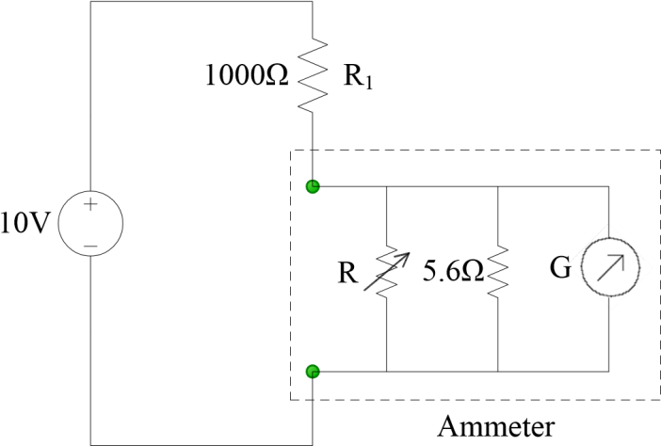

**PROCEDURE:**

* This galvanometer can measure current about **0-300 µA.**
* Different galvanometers have different internal resistance ranges from **130-150 ohms**.
* We measure the internal resistance by using **DMM**.
* Now we will convert our galvanometer into ammeter, ranges from **0 mA** to **10mA**.
* Galvanometer should give full deflections when the current is maximum i.e. **300 mA**.
* Connect the equipment by using the above diagram.

**CALCULATIONS:**

We have,

If ***i* = 10 mA** then ***ig* = 300 µA** and ***is* = 9.7 mA** (***is*** is the current flowing through the shunt resistance ***Rs***).

Suppose the internal resistance ***Rg*** of the galvanometer is **136 Ω** then,

*is = Rg / (Rg + Rs) I*

*Rs = Rg (i /is) − Rg*

*Rs = (136) (10/ 9.7) −136*

***R= 4.20 ohm***

The design of the voltmeter has two constraints:

* The actual value of the internal resistance (*Rm*) of the galvanometer is unknown.
* If we found the actual value of internal resistance (*Rm*) still it might be really fortuitous, if the calculated value of the resistance *R* is present in laboratory.

So to overcome these two constraints a circuit is build. In this circuit, a variable resistance (1 kΩ) has to be attached in parallel with the galvanometer. The value of the variable resistance is slowly varied until maximum deflection of the galvanometer is achieved, that’s why our ammeter design is complete and calibrated for **0 mA** to **10mA** measurement.

**TESTING THE DESIGNED AMMETER:**

To test the designed voltmeter:

* Remove the 10 V supply from the designed ammeter unit.
* Make a circuit by connecting the resistors in parallel, on the breadboard.
* By using the designed ammeter, measure the current across each resistor and record it. Use DMM to verify the current values.

**CIRCUIT DIAGRAM:**

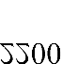

Test circuit to validate the ammeter design

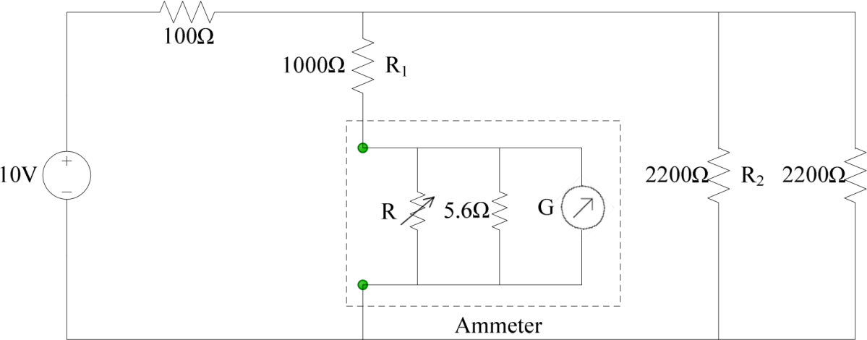

**OBSERVATIONS AND CALCULATIONS:**

|  |  |  |  |
| --- | --- | --- | --- |
| Nominal value of  resistance (Ω) | Current measured by the designed ammeter (A) | Current measured by the DMM (A) | % Difference |
| *R1 = 400* | **3.42** | **2.13** | **46.4%** |
| *R2 = 2200* | **3.33** | **3.00** | **10.4%** |
| *R3 = 3200* | **2.66** | **3.75** | **34.0%** |

**RESULT:**

1/Req = 1/R1 + 1/R2 + 1/R3

Req= **3.22 Ω**

Total Current measured by Designed Ammeter = 3.42+3.33+2.66

= **9.41 A**

Total Current measured by DMM = 2.13+3.00+3.75

= **8.88 A**

Percentage Error = **5.59 %**

**SAFETY PRECAUTIONS:**

* Make sure all power supply is off before connecting or disconnecting the components.
* Ask your instructor to check the circuit before turning on the power.
* When measuring voltage or current, make sure the DMM is correctly set for what you need to measure.
* Make sure that you correctly measure the current across each resistance. To measure the current across R1 (1kΩ), attach the designed ammeter. Current across other resistances can be measured in a similar manner.